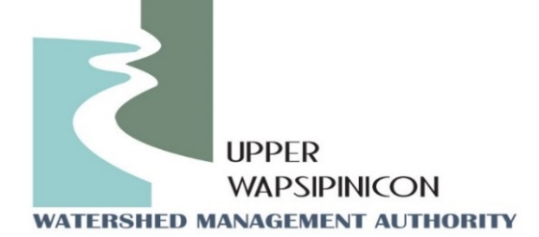
Meeting Information
Tuesday July 15th, 2025
1:30 pm

In-Person Location  Twin Ponds Nature Center  1811 240th St,  Ionia, IA 50645 | Virtual Location/Zoom Link:  Topic: Upper Wapsi WMA Meeting  Time: Jul 15, 2025 01:30 PM Central Time (US and Canada)  Join Zoom Meeting  https://us02web.zoom.us/j/86816144545?pwd=BC3pmft9Jyt6sDIV8KfAZLioDRw80M.1  Meeting ID: 868 1614 4545  Passcode: 235010
Agenda
WMA Board Meeting
Call to order
Roll call and Introductions
Approval of Agenda
Approval of the May 1st, 2025 Minutes
New Business
Election of Officers for July 1st, 2024- June 30th, 2025- John Kurtz
Existing Officers (July 1st, 2024-June 30th, 2025)
Board Chair-John Kurtz, Buchanan County Supervisor
Vice Chair-Orlan Love, City of Quasqueton
Treasurer/Secretary, Duane Meihost, City of Frederika
Directors @ Large: Don Shonka, Buchanan County, Matt Kuhn, Chickasaw County, Chris Eiby, Delaware County SWCD, Orlan Love, City of Quasqueton.
Iowa Flood Center – Kate Giannini will provide some program updates as well as updates on newly installed hydrostations.
Watershed Coordinator Update - Ross and Tori:
  - Grant(s) Status
  - WMA coordinator Funding updates
  - Coon Creek WI meeting
Public Comment/ Other Partner Updates:
Opportunity for partners in attendance to update the WMA board on upcoming events or related projects.
Next Meeting Date
Next Meeting: October, 2025

