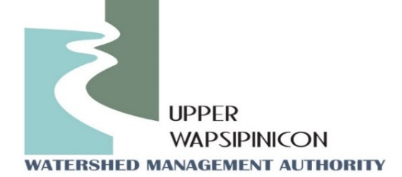
Meeting Information
January 7th, 2025
1:30 pm

In-Person Location  Twin Ponds Nature Center  1811 240th St.  Ionia, IA 50645 | Virtual Location/Zoom Link:  Join Zoom Meeting  https://us02web.zoom.us/j/89054241355?pwd=AJiVf40qOlbD766SDA4uSMav0LuLVV.1  Meeting ID: 890 5424 1355  Passcode: 036176  ---  One tap mobile  +16469313860
Agenda
WMA Board Meeting
Call to order
Roll call and Introductions
Approval of Agenda
Approval of the October 1st, 2024 Minutes
Formally Adopt New Funding Formula (See Oct. 1st Minutes)

New Business
Presentation: American Flood Coalition relay crop – flood-modeling results presented by Ross Evelsizer.
Watershed Coordinator Update - Ross and Tori:
  - Funding request update
  - RCPP Award
Public Comment/ Other Partner Updates:
Opportunity for partners in attendance to update the WMA board on upcoming events or related projects.
Next Meeting Date
April, 2025

