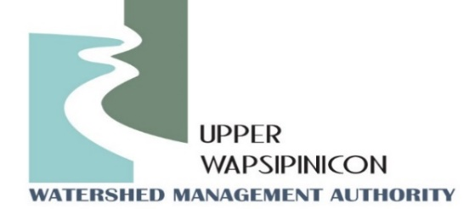**Meeting Information**

January 7th, 2025

1:30 pm

|  |  |
| --- | --- |
| **In-Person Location**  Twin Ponds Nature Center  1811 240th St.  Ionia, IA 50645 | **Virtual Location/Zoom Link:**  **Join Zoom Meeting**  [**https://us02web.zoom.us/j/89054241355?pwd=AJiVf40qOlbD766SDA4uSMav0LuLVV.1**](https://us02web.zoom.us/j/89054241355?pwd=AJiVf40qOlbD766SDA4uSMav0LuLVV.1)  **Meeting ID: 890 5424 1355**  **Passcode: 036176**  **---**  **One tap mobile**  **+16469313860** |

**Agenda**

**WMA Board Meeting**

Call to order

Roll call and Introductions

Approval of Agenda

Approval of the October 1st, 2024 Minutes

Formally Adopt New Funding Formula (See Oct. 1st Minutes)

**New Business**

**Presentation:** American Flood Coalition relay crop – flood-modeling results presented by Ross Evelsizer.

**Watershed Coordinator Update - Ross and Tori:**

* + Funding request update
  + RCPP Award

**Public Comment/ Other Partner Updates:**

Opportunity for partners in attendance to update the WMA board on upcoming events or related projects*.*

**Next Meeting Date**

April, 2025