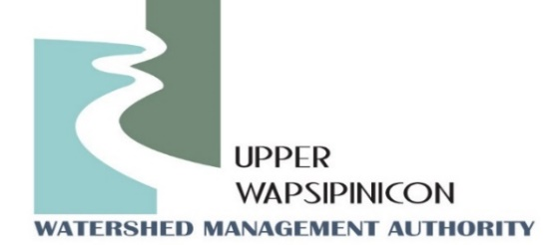**Meeting Information**

October 1st, 2024

1:30 pm

|  |  |
| --- | --- |
| **In-Person Location**  Fontana Park Nature Center  1883 125th St #9695,  Hazleton, IA 50641 | **Virtual Location/Zoom Link:**  **Join Zoom Meeting**  [**https://us02web.zoom.us/j/88999174759?pwd=oIw7RymvhrbMxcQNfpwwbbeMYZN7at.1**](https://us02web.zoom.us/j/88999174759?pwd=oIw7RymvhrbMxcQNfpwwbbeMYZN7at.1)  **Meeting ID: 889 9917 4759**  **Passcode: 549694**  **One tap mobile**  **+16469313860** |

**Agenda**

**WMA Board Meeting**

Call to order

Roll call and Introductions

Approval of Agenda

Approval of the July 11th, 2024 Minutes

**New Business**

**Presentation:** Assessing the Flood Reduction Benefits of On-road Structures: Presentation prepared by Antonio Arenas presented by Tori Nimrod.

**Watershed Coordinator Update - Ross and Tori:**

* Formally adopt new Funding Formula
  + Review draft fundraising letter
* WMA Day event summary
* Grants Update
  + Urban WQI open for Pre-applications
  + City of Fredericksburg

**Public Comment/ Other Partner Updates:**

Opportunity for partners in attendance to update the WMA board on upcoming events or related projects*.*

**Next Meeting Date**

January, 2025