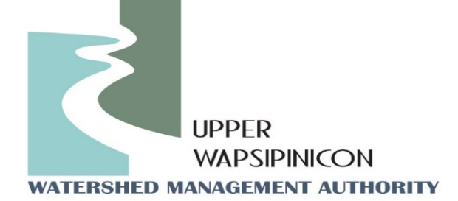
Upper Wapsi River WMA Meeting
Fontana Nature Center
Sept. 12th, 2023
1:30 pm

Minutes

The meeting was called to order by WMA Chairman, John Kurtz at 1:30 pm.
Motion to approve the agenda. Motion was made by Randy Leach and seconded by Sean Dolan. Motion Passed.
Attendees: John Kurtz, Buchanan County Supervisor, Chris Eibey, Delaware SWCD, Ross Evelsizer, Northeast Iowa RC&D, Tori Nimrod, Northeast Iowa RC&D, Orlan Love, City of Quasqueton, Randy Leach, City of Fredericksburg, Kip Ladage, Bremer County SWCD, Sydney Hartogh, Mitchell County, Ron Lenth, Bremer County SWCD, Trevyn Cunningham, Central City, Brian Keierleber, Buchanan County Engineer, Duane Meihost, City of Frederika, Sean Dolan, Buchanan SWCD, Dan Cohen, Buchanan County Conservation.
Motion to approve the Minutes from June 6th, 2023. Motion was made by Orlan Love and seconded by Kip Ladage. Motion Passed.
New Business
Watershed Coordinator Update - Ross and Tori:
Coordinators, Ross Evelsizer and Tori Nimrod opened the discussion by showing attendees the www.upperwapsi.org website and its functions. They first outlined the virtual tour that is available on the website of practices installed through the IWA project. Viewers can interactively click on project sites and view a short description of the project. It is a great tool to show boards and legislators. Coordinators also reminded folks that the watershed plan is located on the website along with information about the WMA board and meetings. Ross explained that the plan is a great place to update yourself on the work and goals of the WMA. It is a great tool to show legislators and member boards and commissions in an interactive way. One useful tool on the website is the subwatershed section that outlines the results of the Agricultural Planning Framework GIS mapping tool. This tool uses elevation and flow data to predict where conservation practices can go in the landscape. The Website shows the results of this tool for each subwatershed in the Upper Wapsi. Practices like grass waterways, contour buffer strips and wetlands are mapped on the landscape. Great tool for seeing what watershed landowners can potentially implement on their property, as well as a great tool for watershed professionals looking for potential project locations in the watershed.

The Coordinators also provided an update on a project with the City of Fredericksburg. They recently assisted the City in applying for an IDNR Farmer to Farmer Grant. The project included a dry detention basin located in town that would temporarily store heavy rain events. The detention structure drains approximately 130 acres of mostly ag land. The City and coordinators were notified that the application was awarded, but are still waiting on a contract from the IDNR. They were notified again warning of a few hurdles that need to be taken care of before contract award. One being, due to updates in the definition of underserved communities, the City of Fredericksburg is no longer fits the definition of being an underserved community, therefore, IDNR and Coordinators are working on finding a different metric that would gain them eligible again.

Lastly the coordinators gave attendees an update on the fundraising efforts for the coordinator position. Funds raised so far for this fiscal year is $5,900, which coordinators explained would largely be utilized for water sampling efforts. The orginal goal for the WMA is $18,000, the first year of donations the WMA received $15,500 (22/32 members contributing), the second year the WMA received $12,950 (16/32 member contributing), and this year only 13/32 members donated. Attendees brainstormed ideas to increase funds raised for this next fiscal year. During the first year of donations the RC&D received several ideas are listed below:
- Keep pushing legislators for WMA funding
- Recognize donors on the website
- Explain the success of the WMA in the letter that goes out to entities
- Send out funding request letter in October
- Board members should show the website to their constituents
Coordinators are going to put together a new letter that will be sent out in October, so that as entities are developing their budgets they can account for it early.

- Next Meeting Date: Tori, will send out potential meeting dates for beginning of December.
Meeting Adjourned at 2:20 Motion made by Orlan Love, Second by Sean Dolan. Motion Passed.

