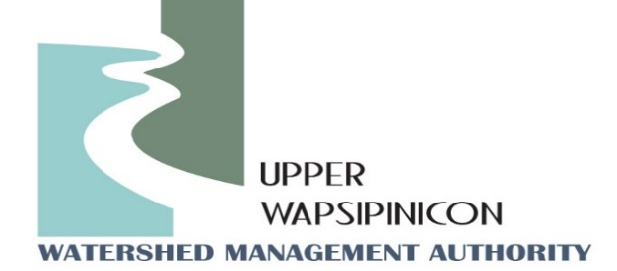
Upper Wapsi River WMA Meeting
Fontana Nature Center
Sept. 12th, 2023
1:30 pm

Minutes

The meeting was called to order by WMA Chairman, John Kurtz at 2:35 pm.
Motion to approve the agenda. Motion was made by Michael O'Loughlin and seconded by Chris Eibey. Motion Passed.
Attendees: John Kurtz, Buchanan County Supervisor, Chris Eibey, Delaware SWCD, Ross Evelsizer, Northeast Iowa RC&D, Tori Nimrod, Northeast Iowa RC&D, Orlan Love, City of Quasqueton, Randy Leach, City of Fredericksburg, Kip Ladage, Bremer County SWCD, Trevyn Cunningham, Central City, Dan Cohen, Buchanan County Conservation, Dean Eastman, Howard County Supervisor, Kate Giannini, Iowa Flood Center, Clayton Ohrt, Buchanan County Supervisor, Laura Alvert and Dave Nuss, City of Sumner, Phil Fangman, Buchanan County, Karmin McShane, Linn County SWCD, Gerald Dennie, City of Winthrop, Ray Armbrecht, City of Fredericksburg, Dennis Goemaat, Linn County Conservation, Rick Wulfekuhle, Buchanan County EM, David Lehman, Bremer County, Kristina McBurney, Rep. Ashley Hinson, Steve Breitbach, Chickasaw County, Michael Mass, Buchanan County Conservation,
Motion to approve the Minutes from Sept. 12th, 2023. Motion was made by Michael O'Loughlin and seconded by Orlan Love. Motion Passed.
New Business
Election of Officers for July 1st, 2023- June 30th, 2024- John Kurtz
Board Chair-John Kurtz, Buchanan County Supervisor – Re-elected to continue serving as board chair
Vice Chair-Kip Ladage, Bremer County
Kip announced his upcoming retirement, therefore resigned as vice Chair. Orlan Love was nominated to serve as Vice Chair and accepted nomination. Motion passed unanimously.
Treasurer/Secretary, Duane Meihost, City of Frederika – Re-elected to continue serving as Treasurer/Secretary
Directors @ Large: Don Shonka, Buchanan County, Matt Kuhn, Chickasaw County, Chris Eiby, Delaware County SWCD, Orlan Love, City of Quasqueton.
No changed to the Directors at Large.
Watershed Coordinator Update - Ross and Tori:
Watershed Coordinators developed a new board member welcome packet to be used as a strategy to bring new board members up to speed on the goals missions of the WMA, and to remind existing board members about their duties as a representative of the Upper Wapsi WMA. Coordinators ask that they share the document with their predecessor should they resign from their prospective boards in the future.

Thanks to Board Chair John Kurtz and others, the FY24 coordinator funding has risen to $13,700 from just $5,900 presented last quarter. Coordinators also sent out the donation request letters for FY2025 and have been receiving some donations for the following fiscal year. Coordinators wanted to remind members that there was some confusion with the timing of the letter, so they will work on being more clear with next season’s letter. Board Chair John Kurtz also discussed changing the funding method from a flat rate to a more quantile approach based on finial resources of the entity, which is similar to what other WMA’s are doing. Coordinators will work with the Executive committee to draft what that looks like for the next quarterly meeting in March.
Water sampling data is complete and coordinators will present results at the next meeting, but will send out raw data to board members for those who are interested. Board member are interested in continuing water sampling even though Coe College lead Martin St. Clare has left the college for a job with the University of Iowa. Coordinators will be in touch with Marty about how to proceed with next season’s sampling analysis.

It is the time of year for WMA’s across the state to advocate for State funding from the legislation. There is movement from the Center for Rural Affairs and other WMA boards to organize a visit to Des Moines on January 29th, 2024. More information about the event will be discussed on a zoom meeting on Dec. 6th. Coordinators forwarded information about the meeting to board members who are interested in learning more. Additionally, Coordinators will summarize the meeting for members who are interested in attending on the 29th.

- Next Meeting Date: Tori, will send out potential meeting dates for beginning of March.
Meeting Adjourned at 3:03 Motion made by Mike O’Loughlin, Second by Orlan Love. Motion Passed.

