Upper Wapsipinicon River Watershed 2023 Sampling Results

The Upper Wapsipinicon River Watershed Management Authority started water sampling with the help from partner organizations in 2015. Since then, samples were gathered in 2015, 2016, 2017, 2019 through 2023. Due to lack of funding and volunteers no samples were collected during the 2018 season. In 2023, samples are collected twice a month during May and June (on the first and third Monday of the month) and once a month (on the third Monday) from July to October. Samples are gathered from 22 locations across the UWRW. This data provides a snapshot of the entire watershed on a given day each month and allows the comparison of one stream/watershed to the next. Water samples are collected on the same day by volunteers and members of private organizations including Iowa State Extension, NRCS, Linn County Conservation, Black Hawk County Health Department, Chickasaw County Conservation, and many more. Once samples are gathered they are packed on ice, and sent to the Coe College laboratory for analysis. The samples are analyzed for concentrations of E.coli Bacteria, Nitrate, Total Phosphate as P, Dissolved Reactive Phosphorus , Chloride , Sulfate, and Total Suspended Solids. Below is a summary of results from the 2023 sampling season.
Table 1. shows the average value for each sampling location in 2023. According to the EPA, Iowa’s nitrate water quality standard for fish and water consumption is 10 mg/L as Nitrate-N. 2021 averages above 10mg/L for nitrate are shown in red. E. coli concentrations above 235CFU/100ml E. coli represents Iowa’s single sample maximum water quality standard for primary contact recreational use. Majority of 2023 sampling location averaged above 253CFU/100ml. These values are also shown in red. E. coli bacteria as an indicator species continues to be a great concern for the UWR watershed. The EPA also recommends concentrations of total phosphorus to be less than 0.1mg/L to prevent excessive growth of aquatic plants in surface waters, which can lead to eutrophication. Phosphorus concentrations often directly correlates to sedimentation and erosion of soils into surface waters. All sampling sites in the Upper Wapsipinicon River Watershed exceed this recommendation. Therefore, phosphorus and sedimentation are another major concern for the watershed.
Table 1. 2023 sampling results for each sampling site.
Site | Subwatershed | TSS | DRP | Cl | NO3-N | SO4 | Ecoli | Total P
Black Hawk 12 | Lower Crane Creek | 10.55 | 0.16 | 33.18 | 2.97 | 22.77 | 518.50 | 0.44
Black hawk 13 | Camp Creek-Wapsi River | 17.45 | 0.11 | 20.02 | 3.44 | 19.98 | 131.13 | 0.30
Bremer 12A | Upper Crane Creek | 13.95 | 0.12 | 26.89 | 3.95 | 18.56 | 1256.86 | 0.29
Bremer 14 | Unknown | 15.15 | 0.18 | 23.33 | 4.40 | 22.67 | 2187.00 | 0.27
Buchanan 15 | Village of Fairbank-Little Wapsi River | 6.45 | 0.16 | 21.00 | 4.21 | 30.64 | 374.63 | 0.29
Buchanan 18 | Otter Creek | 10.25 | 0.12 | 26.28 | 3.90 | 23.86 | 756.38 | 0.22
Buchanan 19 | Pine Creek | 17.50 | 0.12 | 16.60 | 5.92 | 22.88 | 770.25 | 0.14
Buchanan 20 | Silver Creek-Buffalo Creek | 6.40 | 0.10 | 17.49 | 4.00 | 23.11 | 535.50 | 0.19
Chickasaw 3 | Mead Creek | 26.53 | 0.24 | 15.00 | 5.63 | 23.63 | 645.00 | 0.51
Chickasaw 4 | Elk Creek | 22.24 | 0.10 | 19.24 | 6.34 | 10.54 | 973.00 | 0.18
Chickasaw 5 | Village of Ionia-Wapsi River | 38.68 | 0.18 | 22.70 | 4.34 | 17.05 | 470.13 | 0.44
Chickasaw 6 | Spring Branch-Little Wapsi River | 53.63 | 0.15 | 17.00 | 4.62 | 21.01 | 1039.00 | 0.53
Chickasaw 7 | Middle East Branch Wapsi River | 28.21 | 0.12 | 18.85 | 6.00 | 30.84 | 700.38 | 0.30
Delaware 21 | Silver Creek-Buffalo Creek | 3.20 | 0.13 | 23.04 | 9.11 | 19.84 | 835.75 | 0.15
Delaware 23 | Nugents Creek-Buffalo Creek | 5.35 | 0.39 | 29.47 | 8.71 | 20.50 | 1684.86 | 0.68
Linn 22 | Walton Creek-Wapsi River | 48.00 | 0.09 | 22.24 | 3.36 | 21.25 | 128.25 | 0.44
Linn 23 | Nugents Creek-Buffalo Creek | 21.80 | 0.05 | 22.12 | 3.36 | 21.55 | 90.57 | 0.39
Linn 24 | Heatons Creek-Wapsi River | 23.50 | 0.07 | 22.41 | 3.29 | 21.50 | 58.86 | 0.46
Linn 25 | Crows Creek-Wapsi River | 24.25 | 0.06 | 20.15 | 3.11 | 20.81 | 93.50 | 0.35
Linn 26 | Crows Creek-Wapsi River | 8.30 | 0.10 | 17.53 | 5.11 | 20.17 | 292.14 | 0.18
Table 2 shows the yearly average nitrate concentrations for the Chickasaw 6 sampling site in the Spring Branch Little Wapsi Watershed. The Site shows a very high level of nitrate in 2017 likely due to high levels of rain fall recorded during that year. The watershed and most parts of Iowa experienced drought conditions, which is reflected by a low Nitrate average. The data represents a small sample site, therefore, it is unrealistic to determine whether the water body is improving in water quality.

Table 2: Differences in Yearly Average of Nitrate Concentrations for Site Chickasaw 6.
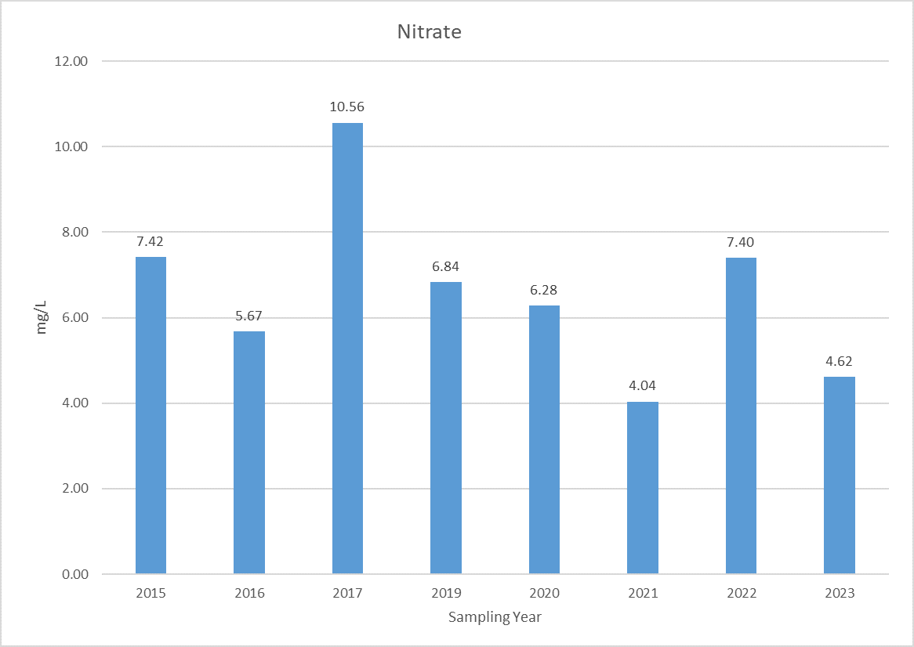

Continued data collection over a wide spatial area of the UWR Watershed allows for a better understanding of the water quality problems in the Watershed, and allows landowners, citizens and organizations to find ways to solve the issues related to poor water quality. Extensive water monitoring data can result in increased funding for effective watershed projects, bringing tens of millions of dollars in state and federal cost share to help private landowners implement voluntary conservation practices, as well as funding for SWCDs and other organizations to hire conservation professionals, including technicians and engineers, to provide free technical assistance to watershed residents.
For more information on the 2022 sampling year, and other Upper Wapsipinicon River Watershed Sampling results go to https://upperwapsi.org/plan/challenges-and-opportunities/water-quality/.

