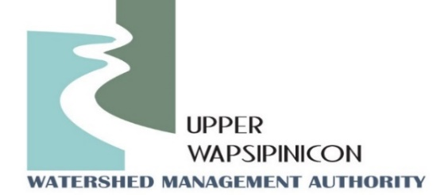
Meeting Information
December 5th, 2023
1:30 pm

In-Person Location  Independence Public Library Community Room  805 1st St. E  Independence, IA 50644 | Virtual Location/Zoom Link:  There will be no virtual option for this meeting

Agenda
Guest Presentation:
Chris Jones: “The Importance of Clean Water”
In his time with the Des Moines Water Works Iowa Soybean Association, and the Iowa Institute of Hydraulic Research (IIHR), Chris Jones has observed and studied ag-related water pollution from both sides of the spectrum. At IIHR he led the Iowa Water Quality Information System (IWQIS) and expanded it from 12 to 66 monitoring stations, which allows researchers and watershed professionals to analyze watersheds and prioritize implementation efforts to improve Iowa’s waterways. As a scientist with extensive experience studying agricultures’ impacts on water quality, he speaks with authority and presents unassailable facts in support of his statements. Additionally, as an excellent writer and speaker, he translates complex processes into language that everyday people can understand.
WMA Board Meeting
Call to order
Roll call and Introductions
Approval of Agenda
Approval of the Sept. 12th, 2023 Minutes
New Business
Review of By-laws Regarding Officers- John Kurtz
Election of Officers for July 1st, 2023- June 30th, 2024- John Kurtz
Existing Officers (July 1st, 2019-June 30th, 2021)
Board Chair-John Kurtz, Buchanan County Supervisor
Vice Chair-Kip Ladage, Bremer County
Treasurer/Secretary, Duane Meihost, City of Frederika
Directors @ Large: Don Shonka, Buchanan County, Matt Kuhn, Chickasaw County, Chris Eiby, Delaware County SWCD, Orlan Love, City of Quasqueton.
Watershed Coordinator Update - Ross and Tori:
- New board member welcome and Information packet.
- Fiscal Year 2024 and FY25 Coordinator Funding Update
Public Comment/ Other Partner Updates:
Opportunity for partners in attendance to update the WMA board on upcoming events or related projects.
Next Meeting Date
March, 2024

