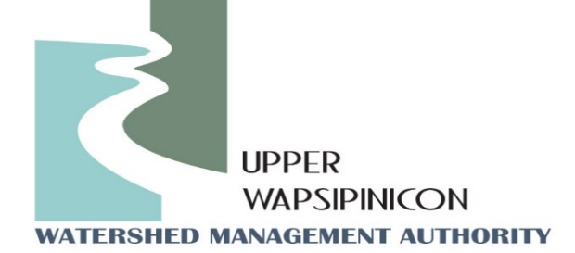
Upper Wapsi River WMA Meeting
Twin Ponds Nature Center
June 6th, 2023
1:30 pm

Minutes

The meeting was called to order by WMA Chairman, John Kurtz at 1:30 pm.
Motion to approve the agenda was made by, Dave Lehman and seconded by Steve Breitbach. Motion Passed.
Attendees: Steve Breitbach, Chickasaw County Supervisor, John Kurtz, Buchanan County Supervisor, Chris Eibey, Delaware SWCD, Ross Evelsizer, Northeast Iowa RC&D, Tori Nimrod, Northeast Iowa RC&D, Orlan Love, City of Quasqueton, David Lehman, Bremer County Conservation, Randy Leach, City of Fredericksburg, Rick Wulfekuhle, Buchanan County EM, Rodger Erickson, Chickasaw NRCS, Chad Humpal, Chickasaw County Conservation, Kip Ladage, Bremer County SWCD, Sydney Hartogh, Mitchell County, Milt Owen, Karmin McShane, Linn SWCD, Ray Armel, Chickasaw County, Ron Lenth, Bremer County SWCD, Trevyn Cunningham, Central City, Brian Keierleber, Buchanan County Engineer.
Motion to approve the Minutes from March 7th, 2023 with the addition of Karmin McShane, Linn SWCD to the attendance list. Motion was made by Orlan Love and seconded by Steve Breitbach. Motion Passed.
New Business
Multi-Cropping Iowa Project Presentation – Ross Evelsizer, NEI RC&D
Ross Evelsizer, Northeast Iowa Resource Conservation & Development (RC&D), has been exploring the practice of multi-cropping as an effective and economical in-field management practice as a potential watershed management tool. Multi-cropping follows the tenets of soil health improvement and can be considered a regenerative agricultural. RC&D developed a project known as “Multicropping Iowa” in 2018 with the intent of better understanding how various iterations of multi-cropping could be implemented with Iowa producers. Project staff have worked with producers to implement trials throughout Iowa to explore the economic and environmental aspects. Participating producers are having high success by relay cropping cereal grains and soybeans. Relay cropping trials have shown to generate profit margins two to five times higher than sole crop soybean comparisons. Preliminary soil testing results suggest that relay cropping may accelerate soil health benefits such as organic matter content and aggregate stability, both important parameters correlated to water infiltration. Additional benefits of relay cropping include reduced reliance on chemical inputs, production flexibility and market diversification. Producer trial participation has grown each year and lately exceeded available acres through the project indicating producers are eager to try the practice with or without incentives.

Many questions remain unanswered to optimize multi-cropping techniques and maximize the benefits associated with this practice for producers and watershed management. As it stands, multi-cropping shows potential as an effective watershed management tool because of the potential to impact a high percentage of watershed acres, the positive benefits to soil health, water quality, and flood mitigation, and economic benefits encourage producer participation without costly incentive programs. Multicropping Iowa is paving the way for mainstream adoption of innovative practices like relay cropping that have the potential to reshape the agricultural landscape and alter the narrative surrounding agriculture and the environment.

Ross’s presentation is attached with these minutes.

Ross also talked about a recent project in the Turkey River Watershed that resulted in the creation of an educational video. “Watershed Wally” watershed education video featuring the Turkey River Watershed can be viewed at the following YouTube link. https://www.youtube.com/watch?v=fXWOn0D0al8
Watershed Coordinator Update - Ross and Tori:
Center for Rural affairs has been taking the leadership in lobbying for WMA coordinator funding in Iowa’s legislation. Efforts worked to push $250,000 of the $800,000 proposal into the Governor’s budget, when last second cuts failed to follow through. Partners will continue to work in getting the WMA request into next year’s budget.

WMA Coordinators at the RC&D assisted the City of Fredericksburg with a grant application for the Underserved Farmer and Farm Community grant through the Iowa DNR. The grantors received enough completed application to award all the applications. The City and RC&D are currently waiting to hear more from the IDNR about how to proceed with the project. The application included a flood retention project within the City of Fredericksburg to help mitigate flash flooding within the City.

Project Coordinator, Tori Nimrod provided an update on the County creek sign project happening within many Counties in the Upper Wapsi Watershed. Chickasaw, Bremer, and Buchanan Counties all have installed creek signs. Several of them include creeks in the Upper Wapsipinicon River Watershed. She also updated folks to check out the www.upperwapsi.org website to view the Virtual IWA project Tour of installed projects in the Upper Wapsi Watershed.

- Next Meeting Date: Tori, will send out potential meeting dates for beginning of September.
Meeting Adjourned at 2:08 Motion made by Randy Leach, Second by Orlan Love. Motion Passed.

