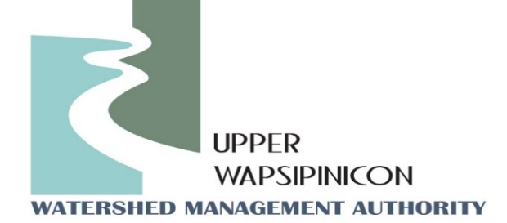
Upper Wapsi River WMA Meeting
Virtual
September 13th, 2022
1:30 pm

Minutes

The meeting was called to order by Chairman John Kurtz at 1:30 pm.
Motion to approve the agenda was made by, Don Shonka and seconded by Chris Eibey. Motion Passed.
Board Members present: Steve Smolik, Mitchell County Supervisor, Don Shonka, Buchanan County Supervisor, John Kurtz, City of Independence, Sheila Steffen, City of Dunkerton, Karmin McShane, Linn SWCD, Chris Eibey, Delaware SWCD.
Others Present: Ross Evelsizer, Northeast Iowa RC&D, Tori Nimrod, Northeast Iowa RC&D, Rick Wulfkuhle, Buchanan County Emergency Manager, Miranda Haes, Iowa DNR, Rochelle Fuller, Regional Director for Senator Grassley.
Motion to approve the Minutes from April 12th, 2022 Meeting was made by Don Shonka and seconded by Steve Smolik. Motion Passed.
New Business
- Watershed Coordinator Update – Ross and Tori
IWA Project Tour
The Iowa Watershed Approach project tour of the Wapsi Watershed was held on June 3rd, 2022. There were 31 participates, 10 of those participants were landowners. Others in attendance were WMA board members and project partners. The attendees visited 10 projects out of a total of 28 projects. Tour locations were chosen based on accessibility, type and time of travel. Tour consisted of a variety of speakers.

Tori and Ross, Upper Wapsi Watershed coordinators: introduced each project and facilitated the
event. Dan Jensen, Shive-Hattery Engineering, Project engineer: Provided summary of the design at each
project location and answered project specific questions. Mike Bretz, Project Landowner: talked about his project and future plans with the resulting pond, as well as how it benefits and fits his operation. Brian Keierleber, Project Landowner/Buchanan County Engineer: Explained experience working with the IWA project and results/benefits of the on-road detention structures Dan Gilles, Iowa Flood Center: Watershed scale flood reduction and water quality benefits. Jason Auel, IDNR, Project Landowner: wildlife benefits of Oxbow restoration project, and project implementation process/experience Katie Hund, Cedar Rock State Park, IDNR: history of Cedar Rock Park and the benefit Oxbow project will have on the Park.

Lunch was provided by Buchanan County Pork Producers, Buchanan County SWCD, and Northeast Iowa RC&D. Stage tour bus for the event was provided by Iowa State Extension. Overall Project Coordinators explained the event was a great success, attendees were very pleased with the projects.

Grant opportunities
Watershed Coordinators also provided an update on other projects happening in the watershed. Northeast Iowa RC&D was recently awarded an Iowa DNR Creek signage grant in the amount of $10,000 to install creek signs in Chickasaw County. Creek signs will be installed on bridges in 7 different locations in the Upper Wapsipinicon River Watershed. Other counties in the Upper Wapsi Watershed also awarded include; Black Hawk, Bremer, Buchanan and Delaware.

The 2023 IDALS Urban Water Quality Initiative grant has been released. Project coordinators explained they are working with the City of Fredericksburg to develop a wetland project, and would like to investigate the Malone Creek project near Independence. This funding opportunity required 50% match. Historically WQI grants have been a maximum of $100,000 grant award, but this year that amount has increased due to extra funds received by IDALS. This grant focuses on water quality improvement eligible practices include rain gardens, wetlands, permeable pavement, native plantings, and other water quality improvement practices. Although practices need to prioritize water quality improvement, flood reduction benefits can also be included. Project coordinators will continue to work with Fredericksburg, the City of Independence, and Buchanan County on project development. Other folks that have project ideas can contact Ross or Tori. Pre-application is due November 18th, 2022.

On-road Structure Analysis

Ross Evelsizer explained a project being conducted by the Iowa Flood Center, Iowa DOT, and Iowa DNR to identify and analyses potential on-road structure locations throughout the state of Iowa. The Upper Wapsi watershed analysis has been completed. Ross and Tori are working out how to receive the results on the analysis.
- Next Meeting Date: Tori, will send out potential meeting dates for beginning of December.
Meeting Adjourned at 1:54: Motion made by Chris Eibey, Second by Sheila Stephen. Motion Passed.

